Installation and use instructions of upper computer software

Special note: This software is only applicable to the Windows operating system.

**Software installation：**

Open the installation software in the following folder for installation

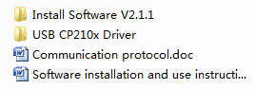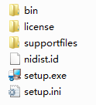

**Driver installation:**

The driver installation only takes the USB interface of the wiring as an example. RS-232/RS-485 is self-wiring by the client. The driver cannot be unified, so the driver cannot be provided. The RS-232/RS-485 cable driver can refer to the USB interface driver installation method.

Step 1: Connect the purchased DC regulated power supply to the computer with the delivered USB cable, turn on the DC power supply, and make them in the power-on state. Note that the USB cable and RS-232 cable cannot be connected to the DC power supply at the same time.

Step 2: Install the corresponding driver

Note that some drivers have the difference between 32-bit and 64-bit. You need to check the bit information of the installed computer and select the corresponding driver to install.



If you do not know the number of digits to install the computer system, you can click "Computer" and right click the property to view it

Click the installation file of the corresponding driver, complete the installation of the driver according to the prompted steps, and restart the computer after the installation of the driver.

Step 3: Right click my computer to find the device manager, click the port (COM and LPT) column on the device manager, and check whether the port has identified the installed port, as shown in the following figure:

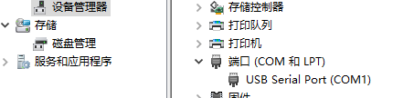

If there are many COM ports connected to your computer, you can plug and unplug the USB cable to confirm whether the COM port connected to the DC power supply can be identified normally, that is, the USB driver has been installed successfully, and remember the COM number connected to the DC power supply.

Step 4: Open the DC power supply software to start the operation of the DC power supply upper computer software.

Step 4: Open the DC power supply software to start the operation of the DC power supply upper computer software.

